Trnava
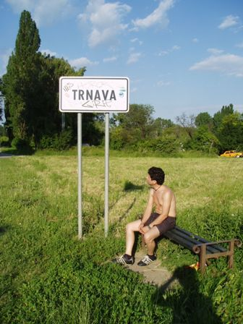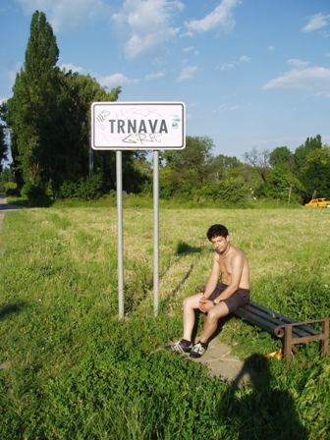
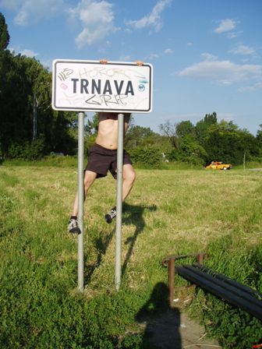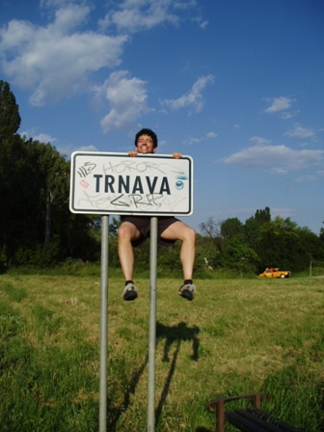
After the bike trip to Budmerice we spent a few more days in Trnava with Lubka’s family and friends eating and drinking and slovatizing
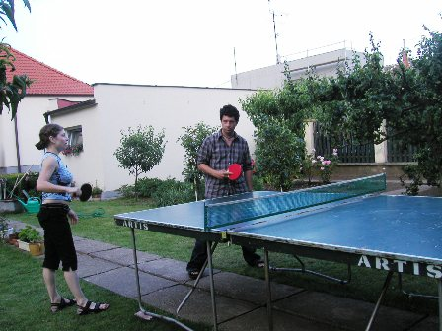
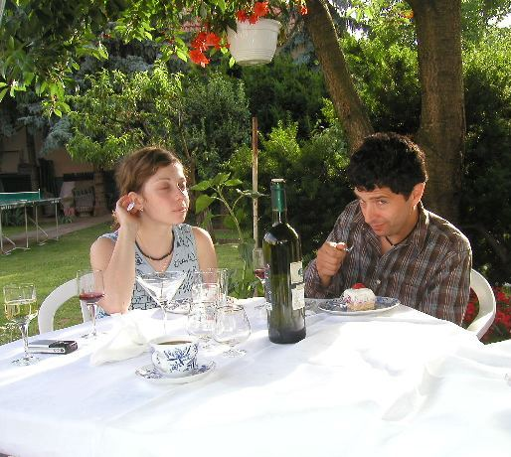
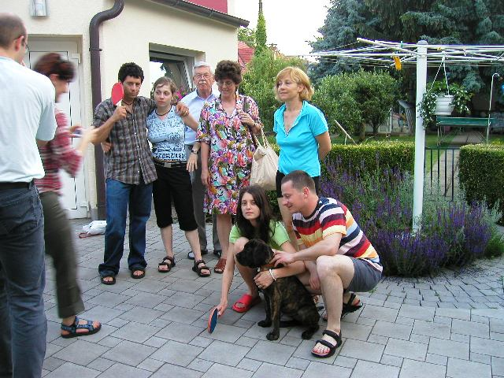
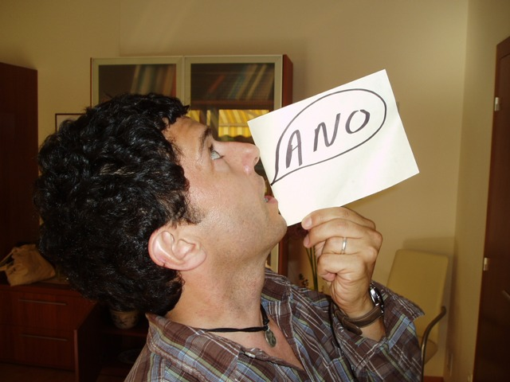
We also took another mild hike to the small Carpathians visiting Smolenice and Jaskyna Driny
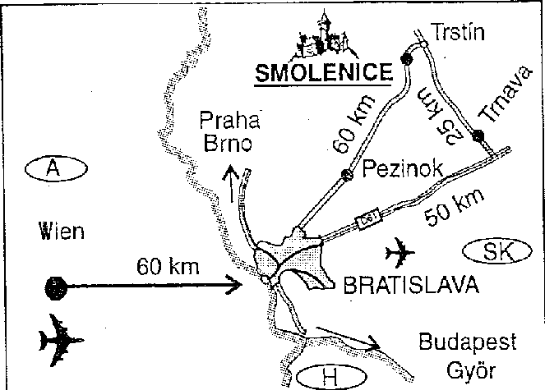
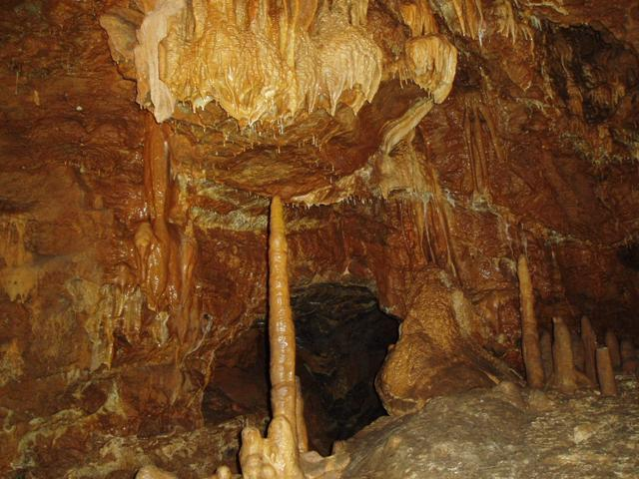

A few years ago I had an MRI and much to my surprise I experienced an acute claustrophobic episode. This was a first for me, and, needless to say for anyone who has experienced such a thing, it was not a pleasant experience. In fact, I was so rattled by it that it took me a few days to regain my equilibrium and was somewhat alarmed to discover that my tolerance for tightly enclosed spaces had suffered some permanent damage. The Driny guided tour was not a short one, maybe 20 minutes, and it took quite an effort of will and concentration to fight that acutely disturbing sensation of suffocation and panic. But I’d still have to confess that I still wasn’t overjoyed by the subterranean experience… it reminded me of the time I was maybe 10-years-old and my Aunt brought me to Boston and I convinced her to let me go into the wax museum by myself only to find that there was something cold and clammy in those dark halls and roped off attractions that didn’t sit right with me. Well the cave with its dark, cold, wet corridors winding to brightly backlit and roped off attractions had a very similar effect on me, like this was perhaps not the best way to meet the cave and its magic. The hike was not without a few pleasant surprises for me however, like the smell of “bear garlic” and the unexpected appearance of a UFO—most likely a bird (like a swallow) or an unidentified flying insect which were there in abundance, but inveigling all the same
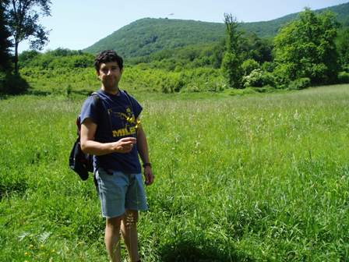
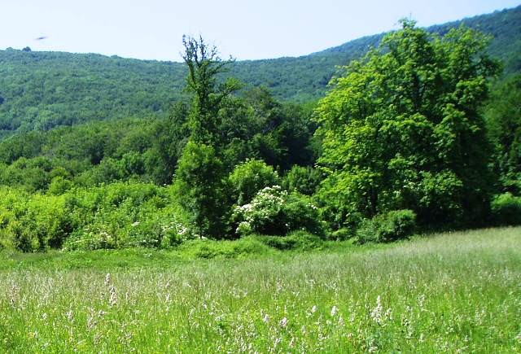
Our next big trip was a journey to Terchova to spend some time on our own at Vysne Kamence exploring the national park of the Mala Fatra. So we also began to pack and plan for a week away from Trnava, and one of the first things we secured was a healthy supply of vino. So early on the morning of our trip to Terchova we went to Spolok sv. Vojtecha where pan professor Hornacek rents out the church property to sell his fine wines and filled the car with 15 liters of frankovka modra, rulandske modre, alibernet and irsaj oliver
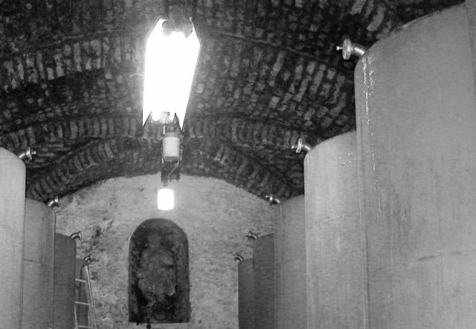
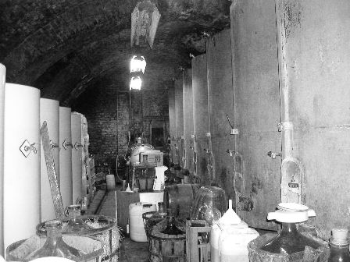
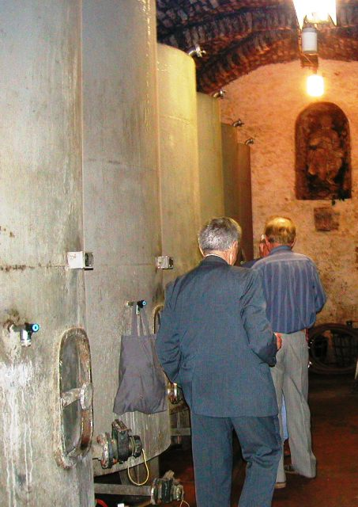
Now we were ready for Terchova and the Mala Fatra !
